**CITRIC ACID**

**HERO**



Citric acid is a widely used organic compound found naturally in citrus fruits and commonly used in food, beverage, and industrial applications. Flexicon bulk material handling equipment is engineered to safely and efficiently convey citric acid through every stage of your process.

**Button**: Talk To Us

**SHELF #1 - PRODUCT DESCRIPTION**

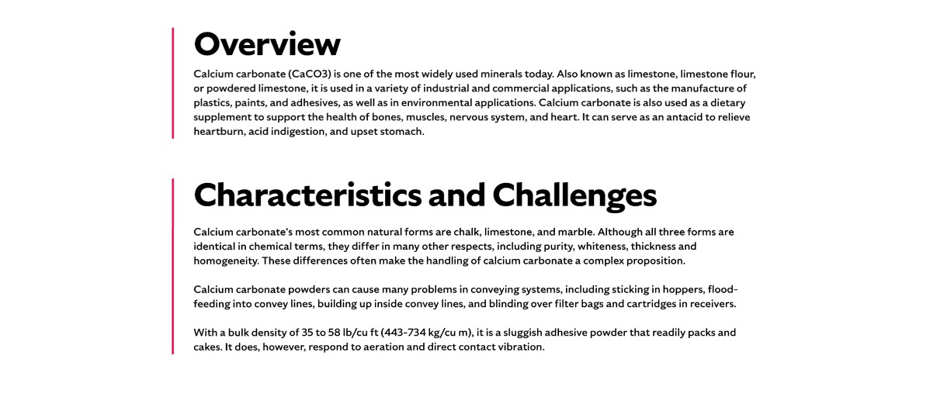

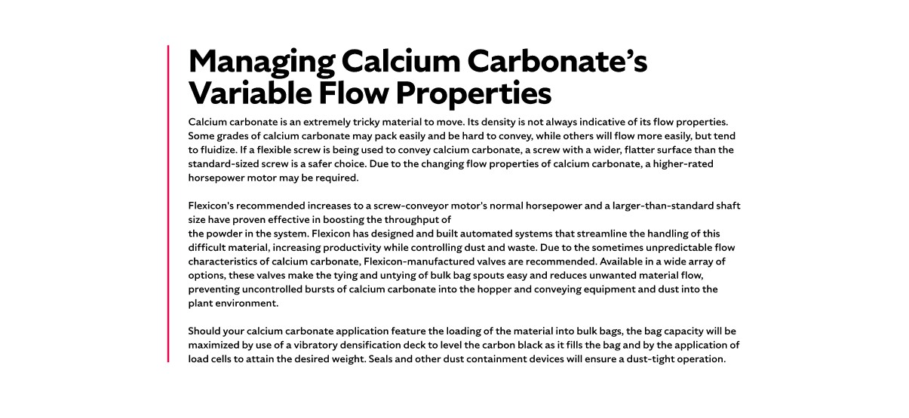

**Overview**

Also known as sour salt or citric salt, citric acid is a tart-tasting, crystalline substance extracted from citrus fruit juices. It’s a key ingredient in food and beverage manufacturing, where it adds acidity to products like soft drinks and canned tomatoes. Citric acid is also valued for its firming properties and is generally recognized as non-toxic and safe for food use. Whether used in large-scale production or specialty applications, citric acid requires precise handling to maintain product integrity and process efficiency.

**Characteristics and Challenges**

At room temperature, citric acid typically appears as a white, crystalline powder. It can exist in either an anhydrous (water-free) form or as a monohydrate, which contains one molecule of water and converts to anhydrous when heated above 172°F (78°C). Citric acid is hygroscopic, meaning it readily absorbs moisture from the air, which can affect its flowability and handling.

Citric acid is both abrasive and corrosive, posing risks to gaskets and metal or non-metal components in conveying systems. Its tendency to solidify and agglomerate—especially in bulk bags—can make unloading difficult without mechanical assistance.

**SHELF #2 - FLEXICON SOLUTIONS**

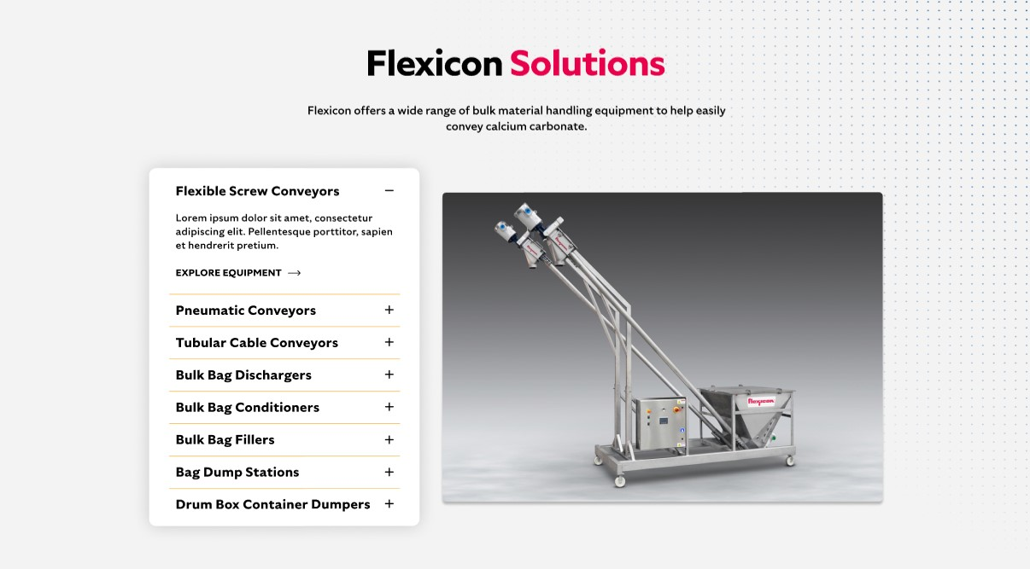

**Flexicon Solutions**

Flexicon offers a wide range of bulk material handling equipment to help easily convey calcium carbonate.

* **Flexible Screw Conveyor**: Flexible Screw Conveyors incorporate a round screw design to gently move free-flowing citric acid while reducing clumping and ensuring steady flow.
* **Pneumatic Conveyors**: Fully enclosed systems keep citric acid dry and dust-free, using filter receivers and pulse-cleaning for clean transfer.
* **Tubular Cable Conveyors**: Perfect for tight spaces, these enclosed systems transport citric acid smoothly along flexible, low-impact paths.
* **Bulk Bag Dischargers**: Unload citric acid safely with spout-sealing and dust-control features that protect operators and maintain cleanliness.
* **Bulk Bag Conditioners**: Apply mechanical pressure to loosen hardened citric acid in bulk bags, restoring flow for efficient discharge.
* **Bulk Bag Fillers**: Ensure precise, dust-controlled filling of citric acid into bulk bags with vibration decks and secure sealing systems.
* **Bag Dump Stations**: Enable safe manual unloading of smaller citric acid bags with integrated dust hoods, filters, and pulse-cleaning systems.
* **Drum Box Container Dumpers**: Transfer citric acid from containers to hoppers with minimal dust and reduced manual handling.

**SHELF #3: LIFETIME PERFORMANCE GUARANTEE**



**Lifetime Performance Guarantee**

All Flexicon equipment and systems are backed by a lifetime performance guarantee. In the rare event that our product fails to meet your performance standards, we will provide the necessary repairs or replacements to keep your conveying line running.

**SHELF #4: CASE STUDIES**



**Overview**:

* Also referred to as sour salt or citric salt
* citric acid is a naturally occurring, tart tasting, organic acid formed in citrus fruits.
* Citric acid is the crystalline material extracted from the juices of these fruits
* Citric acid is used to add an acidic (sour) taste to foods and soft drinks and as a firming compound in products such as canned tomatoes.
* usually classified as non-toxic and safe for food.

**Characteristics**:

* At room temperature, most citric acids are a white, crystalline substance.
* Citric acid can exist either in an anhydrous (water-free) form or as a monohydrate (a compound that contains a single molecule of water). The monohydrate can be converted to the anhydrous form by heating above 172°F (78 °C).
* Most grades of citric acid have an average bulk density of 48lb/ft4.
* most citric acid may also be micronized
* Citric acid is hygroscopic, meaning that humidity and temperature may impact its flow.

**Challenges**:

* be both abrasive and corrosive, so care must be taken to use equipment that can withstand prolonged exposure to this material.
* Citric acid can damage gaskets and fabricated metal and non-metal components in bulk handling material equipment.

**Applications**:

* material's tendency to solidify and agglomerate from storage vessel to processing system - If the citric acid has been transported to the facility in bulk bags, it may have formed into a nearly unmovable solid mass that will require mechanical pressure to break it up, enabling bulk bag unloaders to discharge the citric acid through bag spouts.
* frames used to discharge the bags may still require additional accessories to reduce the need for operator intervention when emptying the citric acid from the bag. This includes features such as spring-loaded frames that will elongate and stretch the bags as they empty and lighten, making them rigid and removing any pockets of citric acid cornered in the bags.
* Bag activating devices are usually effective in agitating the citric acid, dislodging collections of citric acid, promoting a better flow. Some of these bag activating devices also serve as an airtight seal between the bulk bag and the receiving hopper.
* If the citric acid is being added into the processing stream from smaller (>50 lb./22.76 kg.) bags, a bag-breaking station with a dust hood, filtration devices and a pneumatic pulse cleaner is the recommended solution to support the manual unloading of the material. If empty bag disposal is an issue, a dust-tight bag compacting system may be necessary.
* The geometry of the feed hoppers is another important aspect in handling citric acid. To prevent errors in the charging of the conveyor, there may be a need to incorporate devices such as vibrators or mechanical agitators to promote flow. A hopper screen above the receiving vessel will help protect the operators if the citric acid is being dumped manually into a hopper that is equipped with agitating devices.
* If the citric acid is being pneumatically conveyed into a processing system, the blower used to move citric acid through the air line must be sized to meet the demands of the system. Citric acid tends to absorb moisture from the air. If this issue causes excessive clumping, additional devices may be required to reduce the humidity levels or draw moisture from the citric acid prior to its entrance into the conveyor.
* Due to citric acid's crystalline form and its free-flowing nature, a round screw design is commonly used for flexible screw conveying.